Seq2seq chatpot

* I used pycharm to edit and fix the codes in this project.
* I used github to put all my work on.

Step to use:

1. Install all the files from githup and store them in one file
2. Open pycharm and Install pandas, tensorflow, numpy if you haven’t them. 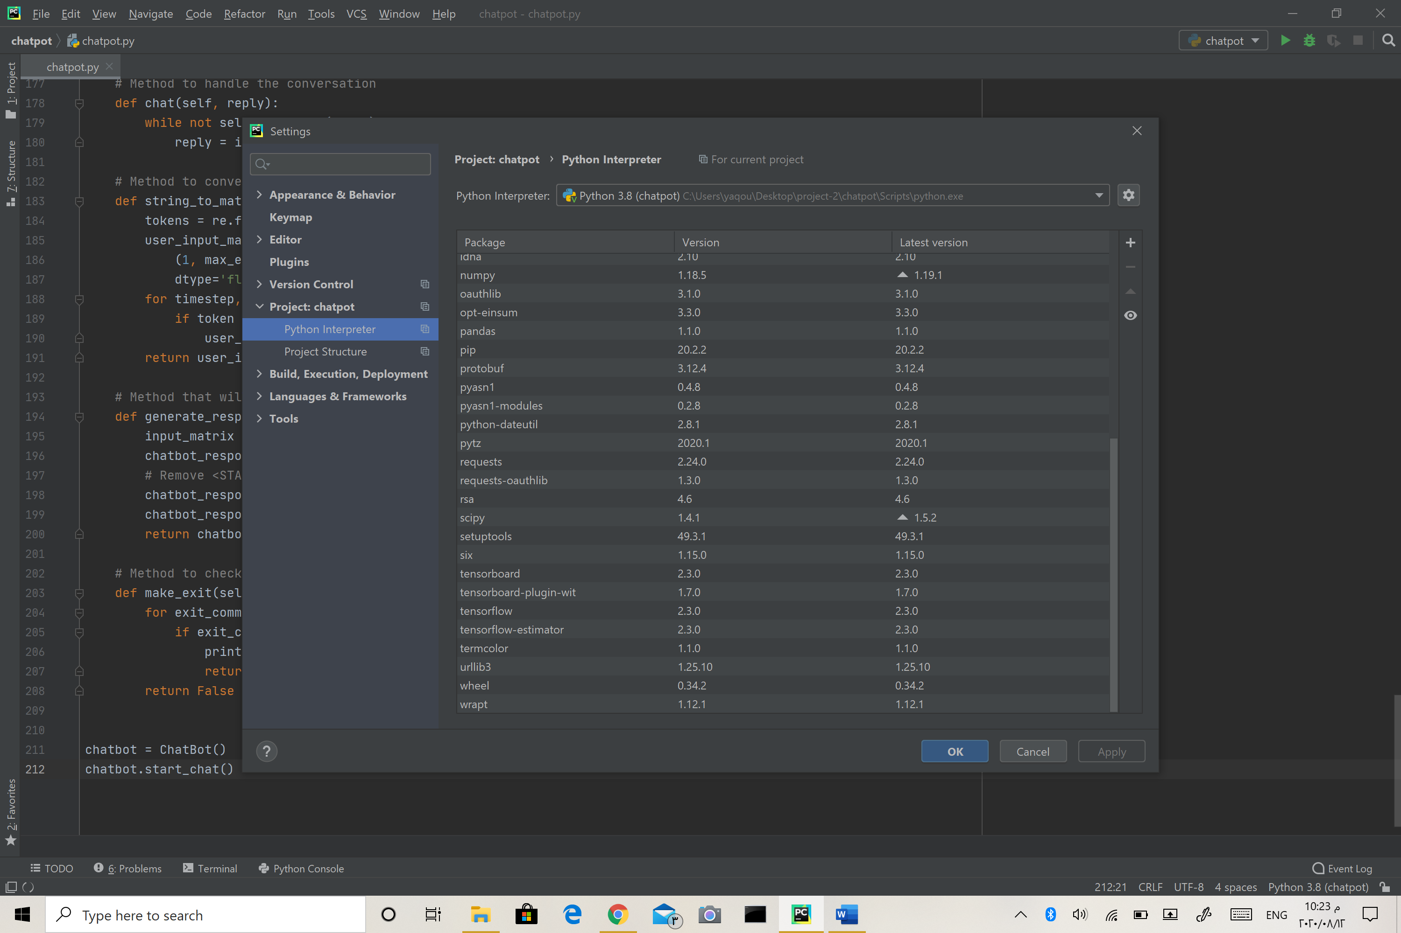
3. Open chatpot.py in pycharm as a project.

Note that all cods work 100%

1. Change epoch and bath size to the amount that you want

Note that epoch = 600 and bath size = 10 in the default options

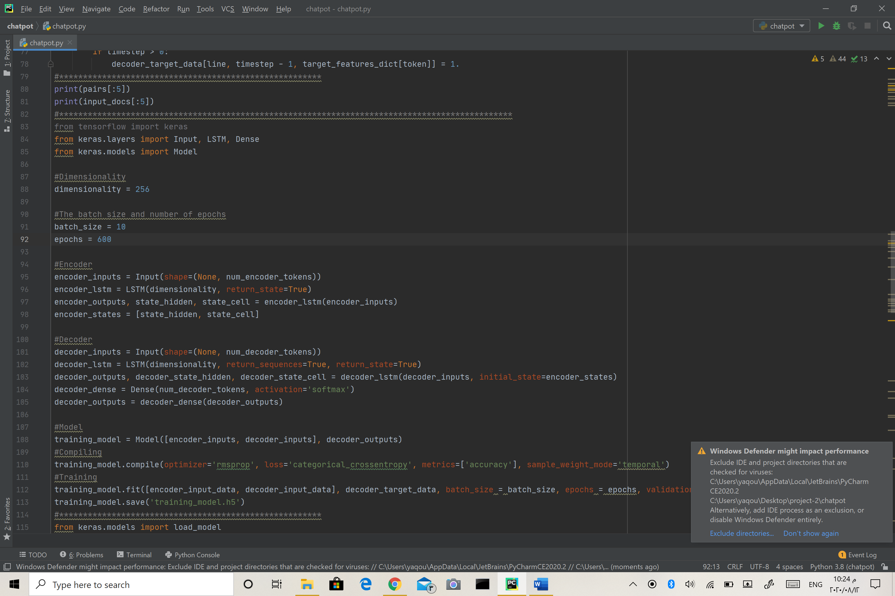

1. And hit run
2. After training the data write anything you want

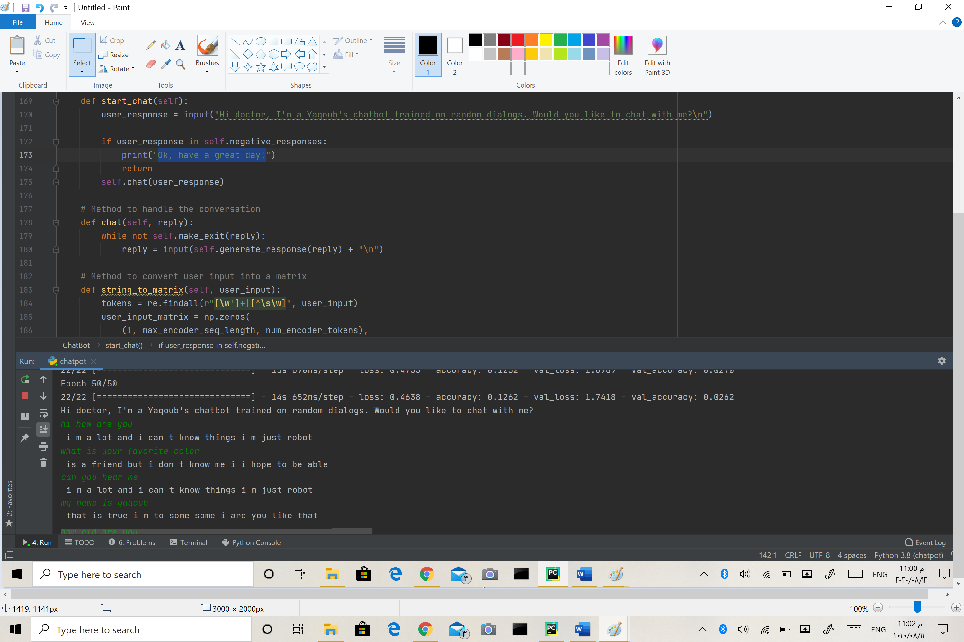

1. Want to exit ???

enter {"quit", "pause", "exit", "goodbye", "bye", "later", "stop"}

more nots:

1. The accuracy is very very bad and the reason is that we used only 400 pairs of the dataset and if we encourage it the accuracy will increase.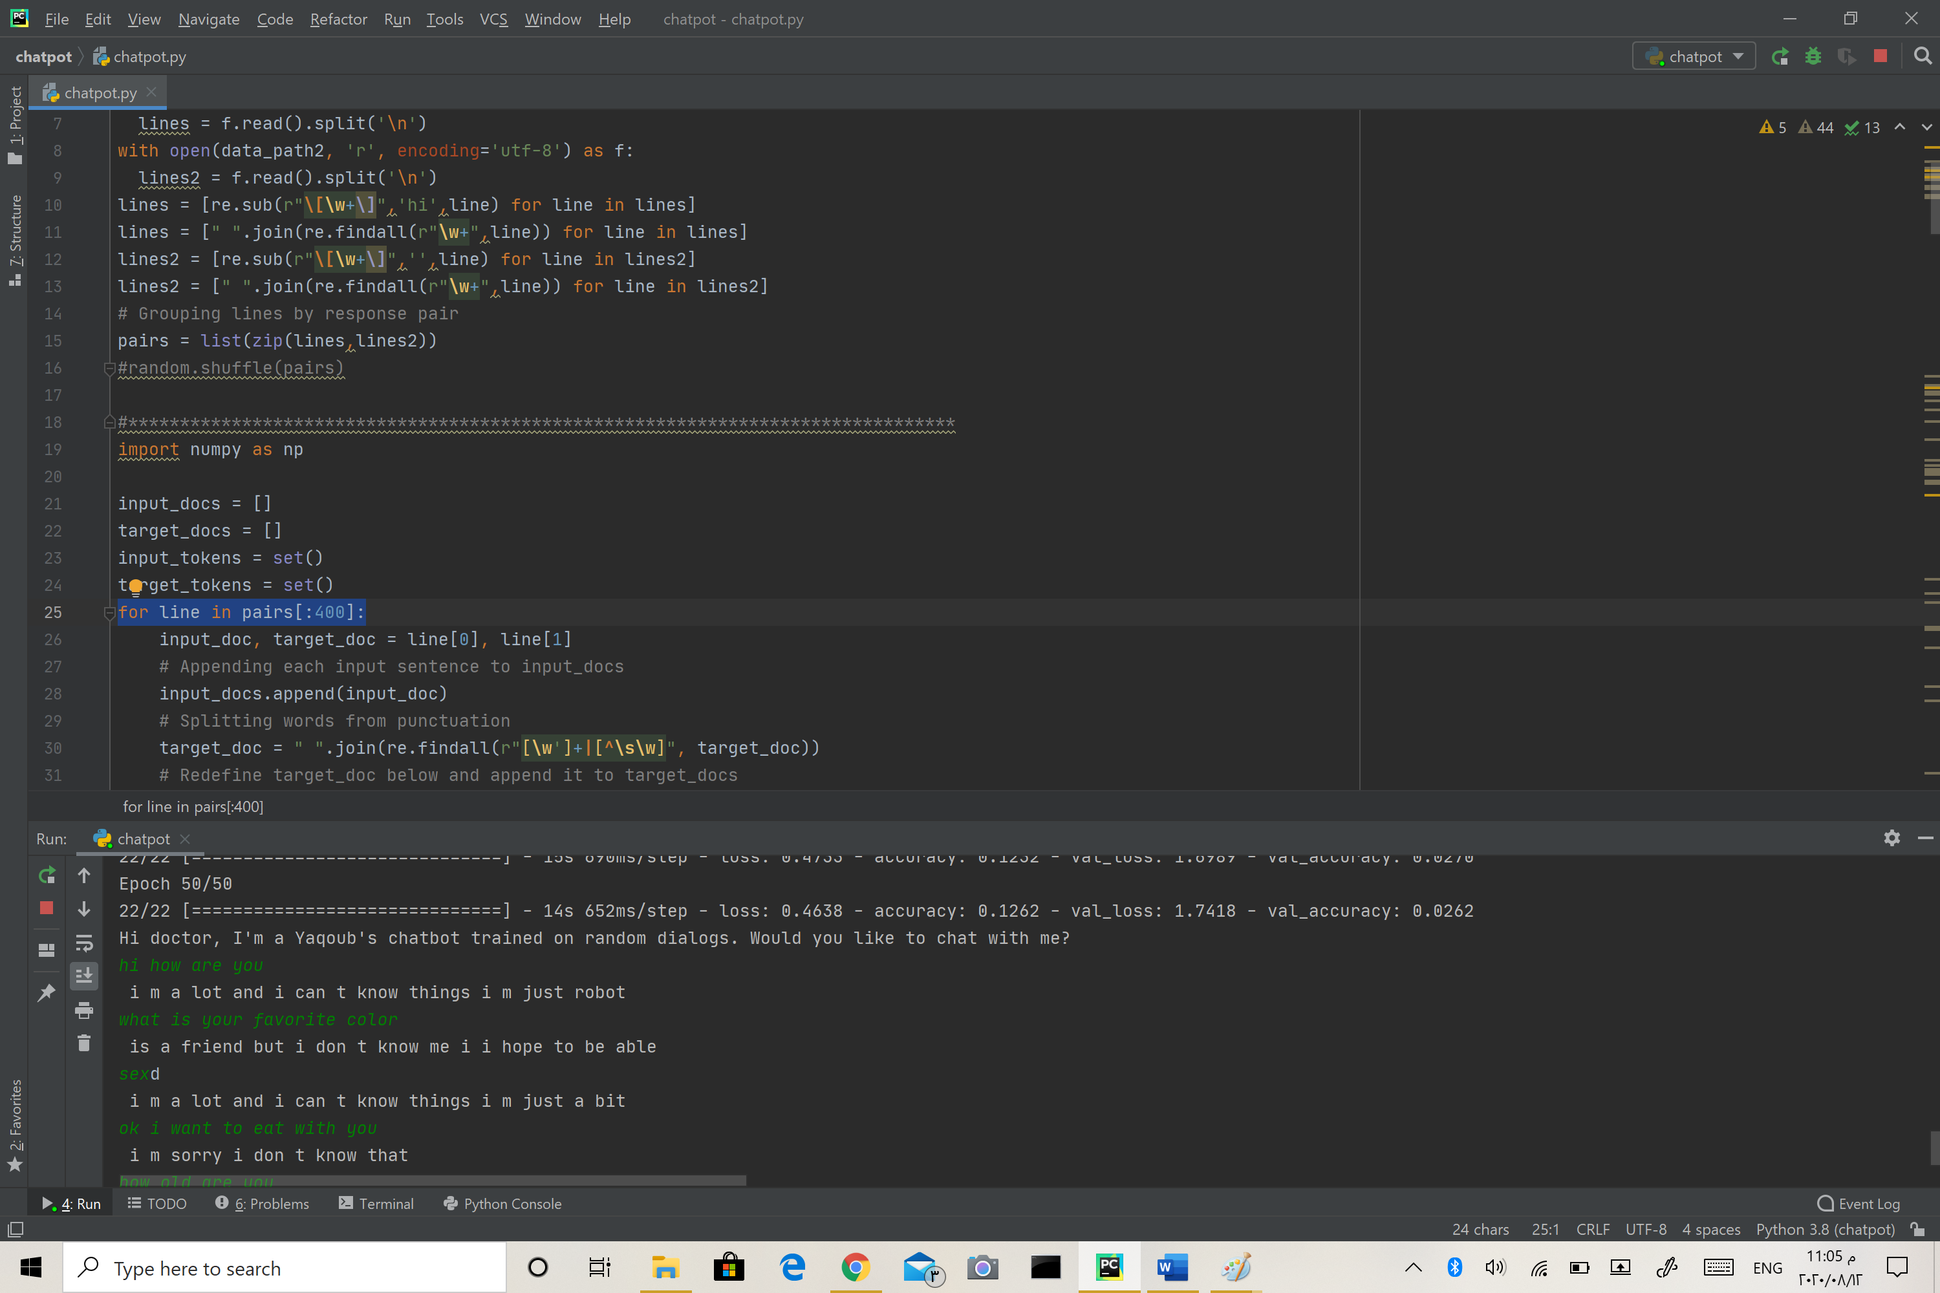
2. The training time is very long
3. After bot salutation if you enter any negative responses ("no", "nope", "nah", "naw", "not a chance", "sorry") the bot will stop and say Ok, have a great day!
4. To train our seq2seq model we will use three matrices of one-hot vectors, Encoder input data, Decoder input data, and Decoder output data. The reason we are using two matrices for the Decoder is a method called teacher forcing which is used by the seq2seq model while training.
5. we are using rmsprop as an optimizer and ategorical_crossentropy as our loss function.
6. If you want to run this project in ubuntu you should to download these files **chatpot.py** , **human_text.txt** , **robot_text.txt** you can get them from this link <https://github.com/yaqoub-bau/seq2seq_chatpot> and then install these libraries to help you run this project: **numpy, pandas, tensorflow, keras**

note that without the previous libraries you can’t run the code